**ONLINE BUS TICKET BOOKING SYSTEM**

**A Java Programming II Project**

**By**

**Rasmi Jati**

**Exam Roll No: 7930/17**



**Submitted to:**

**Dinesh Bajracharya (Lecturer)**

**Roshan Rijal (Project Supervisor)**

**Kantipur College of Management and Information Technology**

In Partial Fulfillment of the Requirements for the Course Java Programming II

Mid Baneshwor, Kathmandu

March, 2020

**PREFACE**

The project is about **“Online Bus Ticket Booking System”** that is developed with the intensity of helping those people who travels from one place to another by saving both time and money. The report provides the basic knowledge of database and web programming in which different technologies such as **JAVA, CSS, JSP, SERVLET** and **MYSQL** is used.

The whole project have been divided in four chapters.

* Introduction
* Requirements and design
* Development and testing
* Conclusion

**ACKNOWLEDGEMENT**

Presentation, inspiration and motivation have always played a key role in the success of any venture.

I express my sincere thanks to our respected sir Mr. Dinesh Bajracharaya and our project supervisior Mr. Roshan Rijal for providing their invaluable guidance, comments, supports, encouragement and suggestions in completion of my project.

Last, but not the least, my parents are also an important inspiration for me. So with due regards, I express my gratitudes to them.

**LIST OF TABLES**

* + - 1. Admin Login Table
      2. Route Table
      3. Register Table
      4. Booking Table

**LIST OF FIGURES**

* + 1. E-R diagram

3.1.1 Login Page

3.1.2 Admin Login Page

3.1.3 Registration Page

3.1.4 Ticket Booking Page

3.2.1.1 Test for Invalid Login Data

3.2.1.2Test for Valid Login Data

3.2.2 Viewing Ticket Detail of User

3.2.3 Deletion of Ticket

3.2.4 Update of Ticket

3.2.5.1 List of Registered Passengers

3.2.5.2 Form to Delete Account of passenger

3.2.5.3 Message after Deletion of Passenger’s Account

3.2.5.4 List of Passengers after Deletion of a passenger

**Table of Contents**

CHAPTER I 6

INTRODUCTION 6

1.1 Existing System Introduction 6

1.2 Developed System Advantage over Existing System 6

1.3 Limitations of the Developed System 6

CHAPTER II 7

REQUIREMENTS AND DESIGN 7

2.1 Requirements 7

2.2 Design 8

2.2.1 System Design 8

2.2.2 Relational Database Tables 9

CHAPTER 3 10

DEVELOPMENT AND TESTING 10

3.1 Development 10

3.1.1 Login Form 10

3.1.2 Admin Login Form 10

3.1.3 Registration Form 11

3.1.4 Ticket Booking Form 11

3.2 Testing the System 12

3.2.1 Test for User Login 12

3.2.2 View Ticket Details 14

3.2.3 Deletion of Ticket 14

3.2.4 Update of Ticket 16

3.2.5 Account Deletion of Passenger 17

CHAPTER 4 19

CONCLUSION 19

# CHAPTER I

# INTRODUCTION

This Online Bus Ticket Booking System is developed in Java as a web-based project.This project is developed for those people who wants to travel and explore new places. People have to wait long hours in bus ticket counter to get the ticket for the bus so this system might be of great use for those people as they can book the tickets online easily. The purpose of developing this system is to easily book ticket without having to go to the bus counter for the ticket.

## 1.1 Existing System Introduction

The existing system of bus ticket booking is time-consuming for both bus ticket booking company and passengers. Ticket booking do not support for long time period. Accessing and updating the system is slow. And overall, the system is not web-based but is file-based processing.

## 1.2 Developed System Advantage over Existing System

The developed system is a web based system that allows online bus ticket booking.

**Advantages:**

* Easy to use
* Time saving
* Accessing and updating is fast
* Ticket booking support up to 1 year

## 1.3 Limitations of the Developed System

The following are the limitation of this system.

* Form validation is not done properly.
* Seat choosing facility is not available.

# CHAPTER II

# REQUIREMENTS AND DESIGN

## 2.1 Requirements

The following points describe what this system can do.

* Booking and cancellation of the bus tickets.
* Update and view of the tickets.
* Maintain the passenger’s ticket booked records and the passengers personal records.
* Booking tickets is less time consuming.
* Free registration for customers.

## 2.2 Design

### 2.2.1 System Design

Customer

has to

Register

Login

for

Booking

**Figure 2.2.1: E-R diagram**

### 2.2.2 Relational Database Tables

|  |  |  |  |
| --- | --- | --- | --- |
| **S.No.** | **Field name** | **Type** | **Description** |
| 1. | Admin_id | Number | Store id of admin |
| 2. | Email | Text | Store email of admin |
| 3. | Password | Text | Store password of admin |

**Table 2.2.2.1: Admin Login Table**

|  |  |  |  |
| --- | --- | --- | --- |
| **S.No.** | **Field name** | **Type** | **Description** |
| 1. | Route_id | Number | Store id of route |
| 2. | Route | Text | Store name of route |
| 3. | Price | number | Store total amount of particular route |

**Table 2.2.2.2: Route Table**

|  |  |  |  |
| --- | --- | --- | --- |
| **S.No.** | **Field name** | **Type** | **Description** |
| 1. | User_id | Number | Store id of user |
| 2. | Name | Text | Store name of user |
| 3. | Address | Text | Store address of user |
| 4. | Phone number | Number | Store phone number of user |
| 5. | Email | Text | Store email of user |
| 6. | Password | Text | Store the password |

**Table 2.2.2.3: Register Table**

|  |  |  |  |
| --- | --- | --- | --- |
| **S.No.** | **Field name** | **Type** | **Description** |
| 1. | User_id | Number | Store id of user |
| 2. | Name | Text | Store name of user |
| 3. | Ticket_on_date | Date | Store date of ticket for travelling |
| 4. | Route | Text | Store name of route |
| 5. | Price | Number | Store total amount of particular route |
| 6. | Number of days | Number | Store number of days |
| 7. | Number of people | Number | Store number of people |
| 8. | Total fare | Number | Store total price |

**Table 2.2.2.4: Booking Table**

# CHAPTER 3

# DEVELOPMENT AND TESTING

## 3.1 Development

### 3.1.1 Login Form

Login form is developed for the authorized user to do the further process. The unauthorized user are not allowed for further processes.



**Figure 3.1.1: Login Page**

### 3.1.2 Admin Login Form

Admin Login form is developed for the authorized user to do the further process. The unauthorized user are not allowed for further processes.

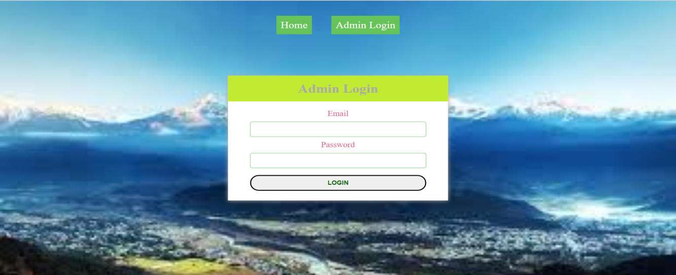

**Figure 3.1.2: Admin Login Page**

### 3.1.3 Registration Form

Registration form is for those people who want the access to our system. The user should register to get authorized for further process.

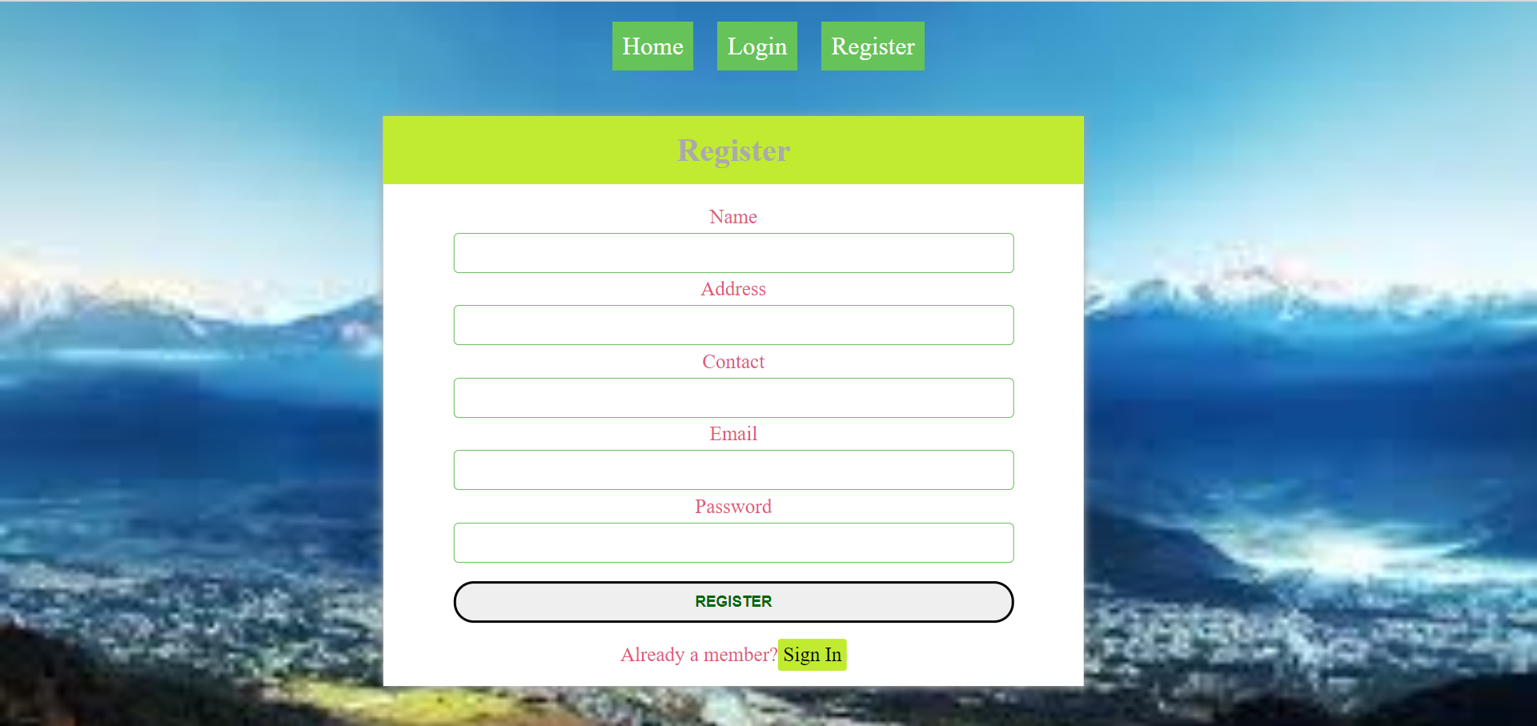

**Figure 3.1.3: Registration Page**

### 3.1.4 Ticket Booking Form

Ticket booking form is to book the ticket by filling the required information

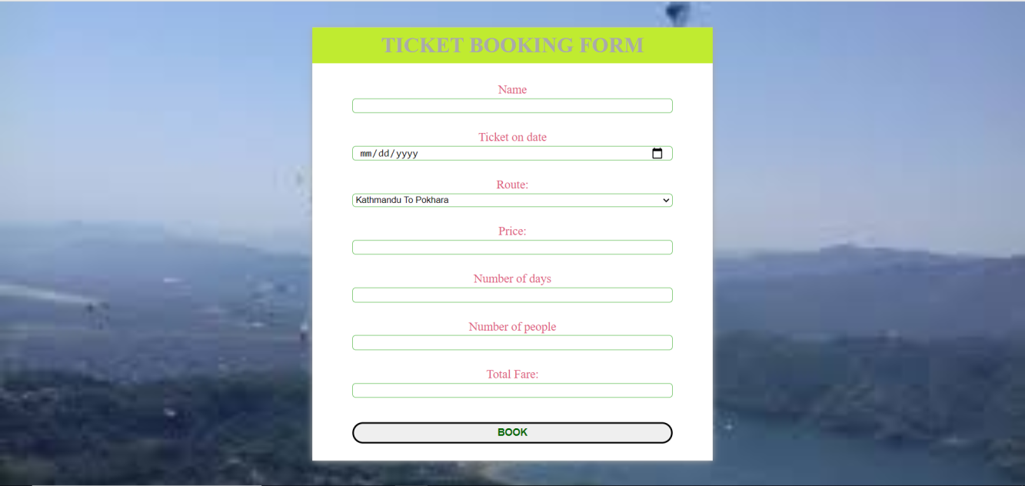

**Figure 3.1.4: Ticket Booking Page**

## Testing the System

Testing is an improvement phase. This phase involves testing of developed system using different form of data.

### 3.2.1 Test for User Login

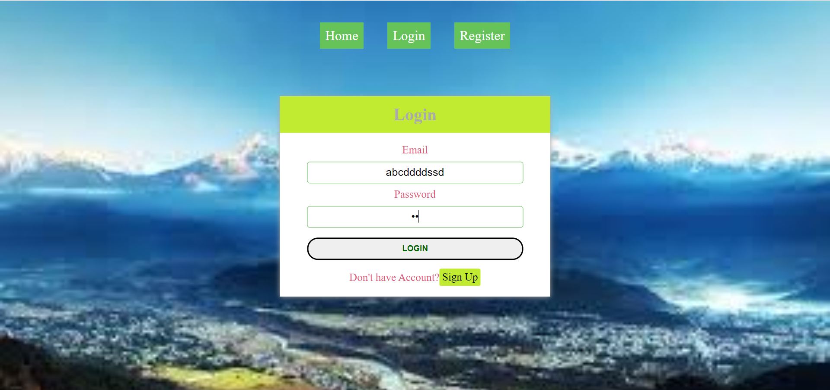

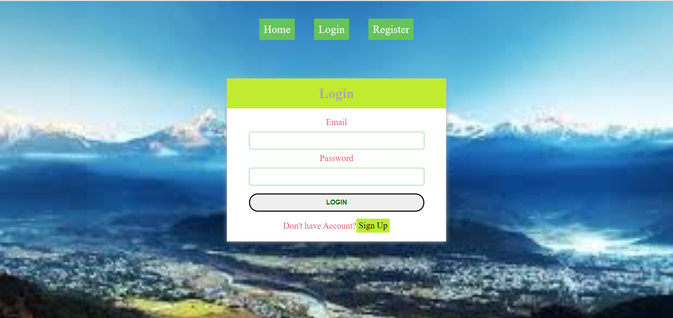

**Figure 3.2.1.1: Test for Invalid Login Data**

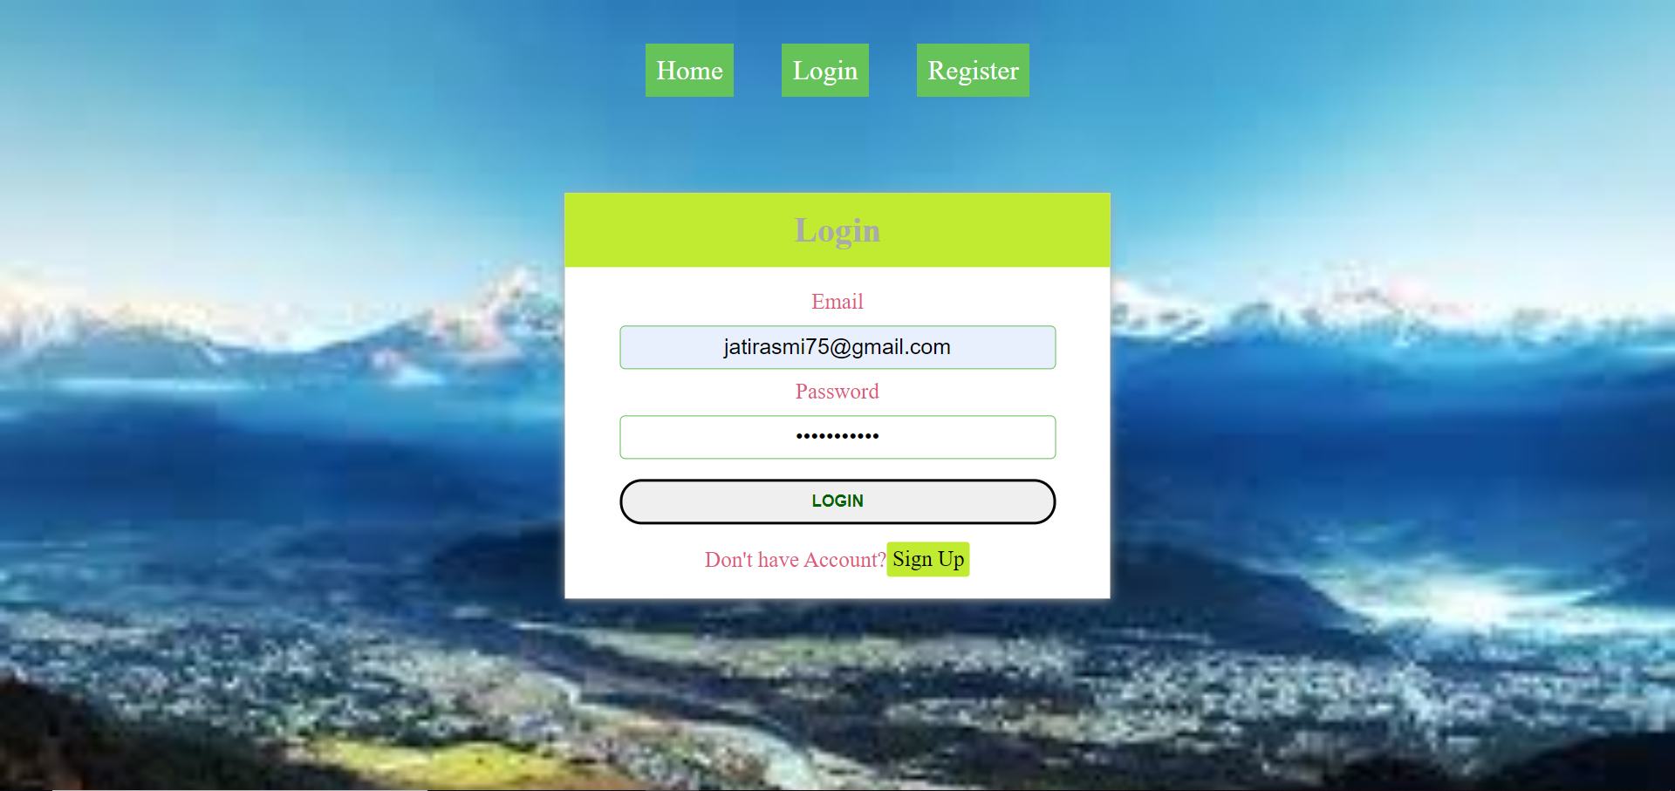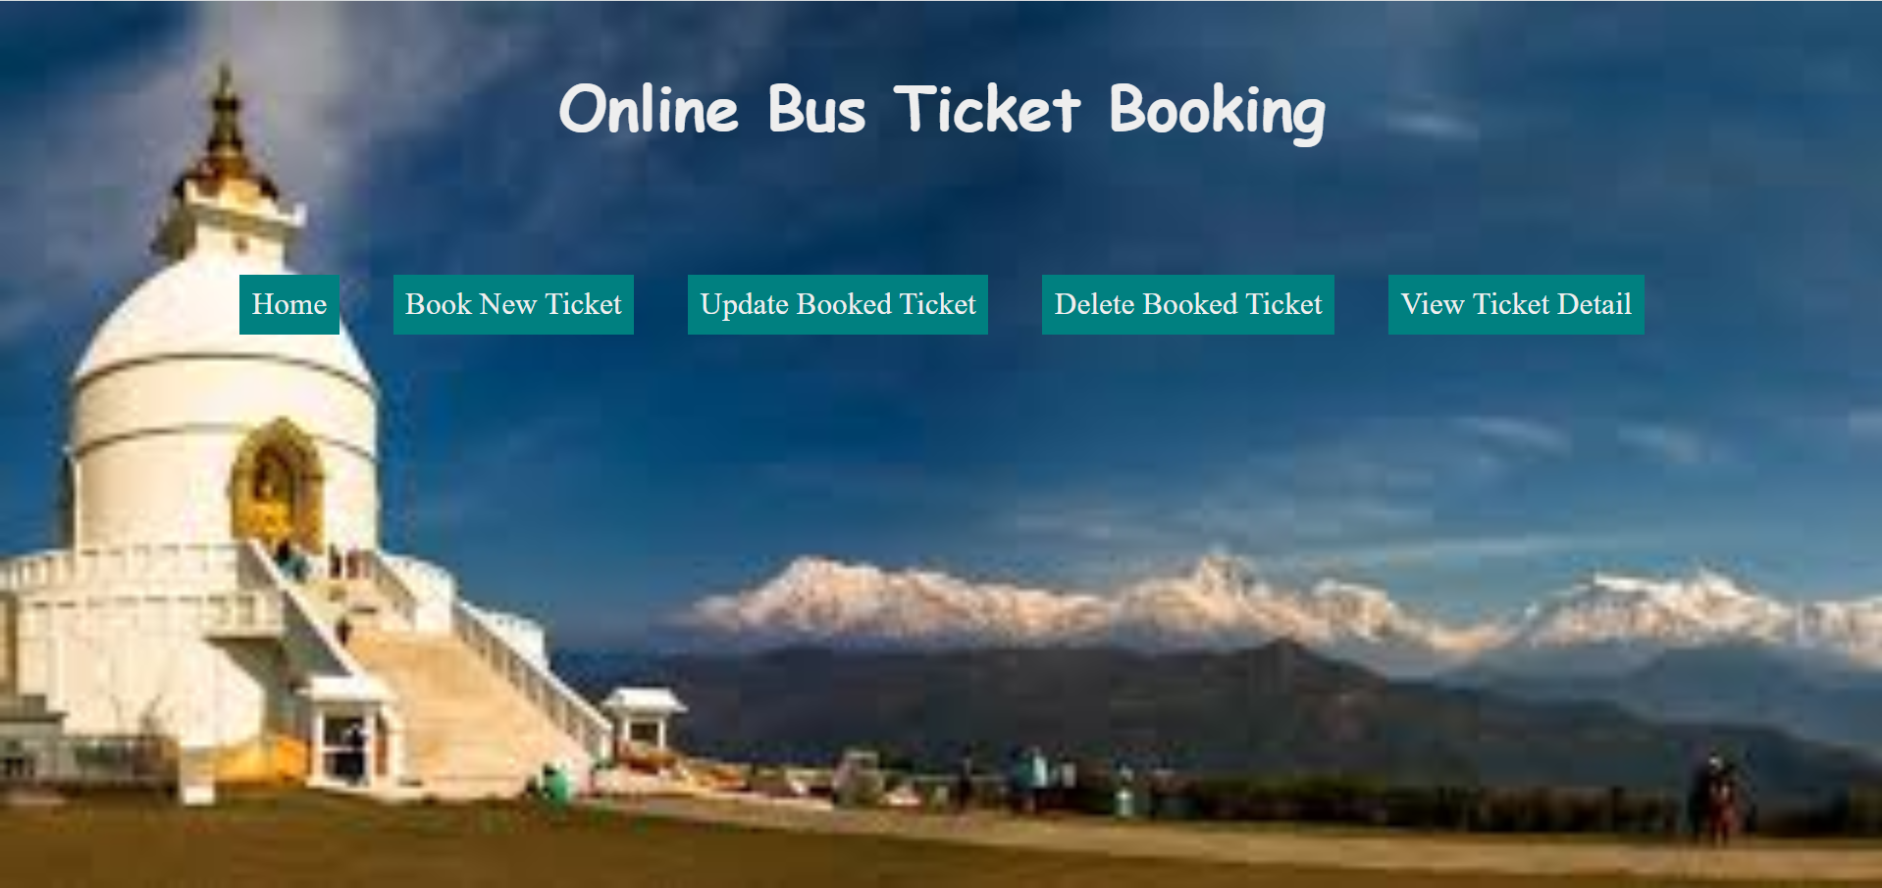

**Figure 3.2.1.2: Test for Valid Login Data**

### 3.2.2 View Ticket Details

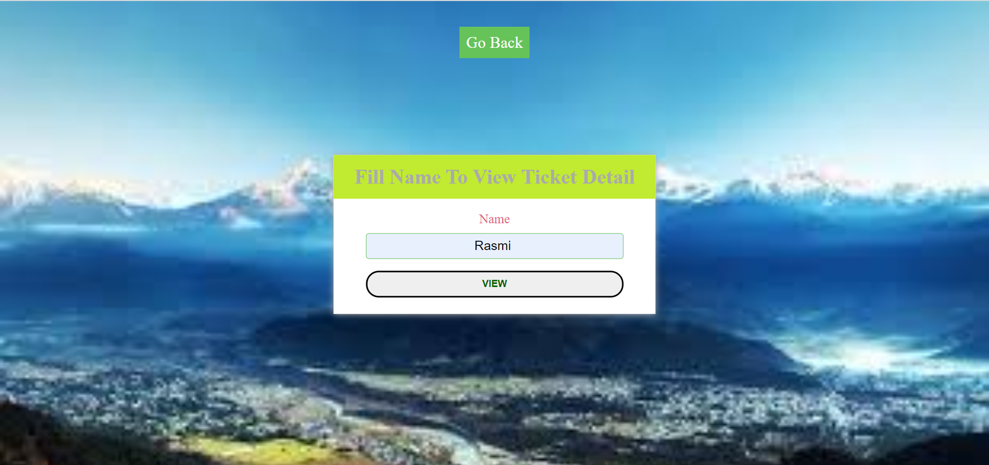

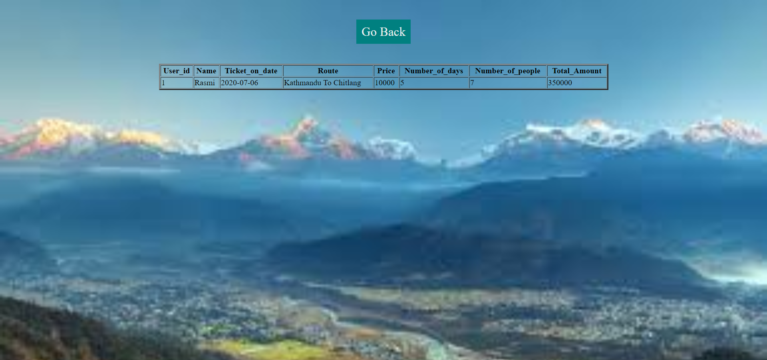

**Figure 3.2.2: Viewing Ticket Detail of User**

### 3.2.3 Deletion of Ticket

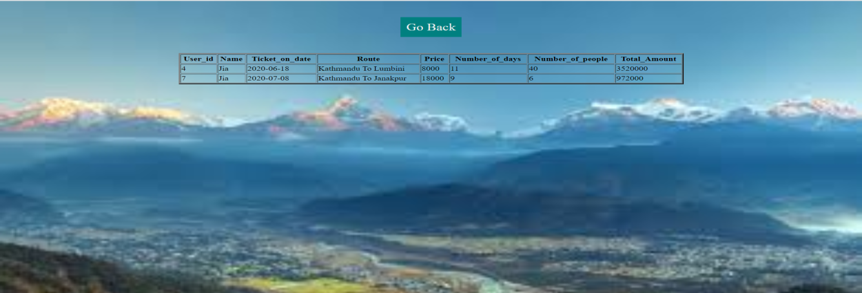

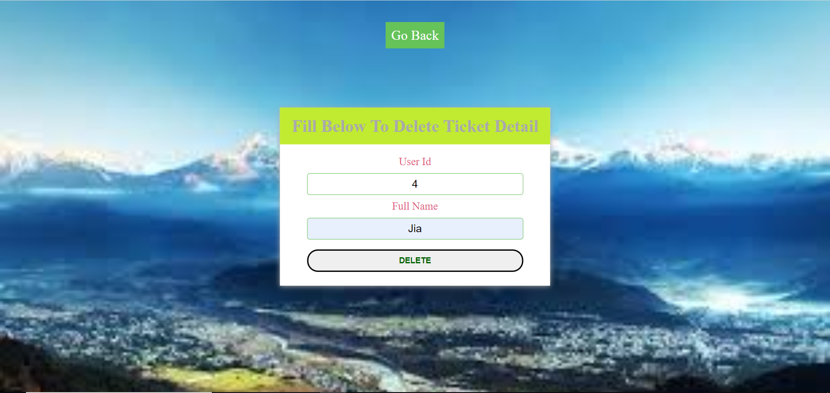

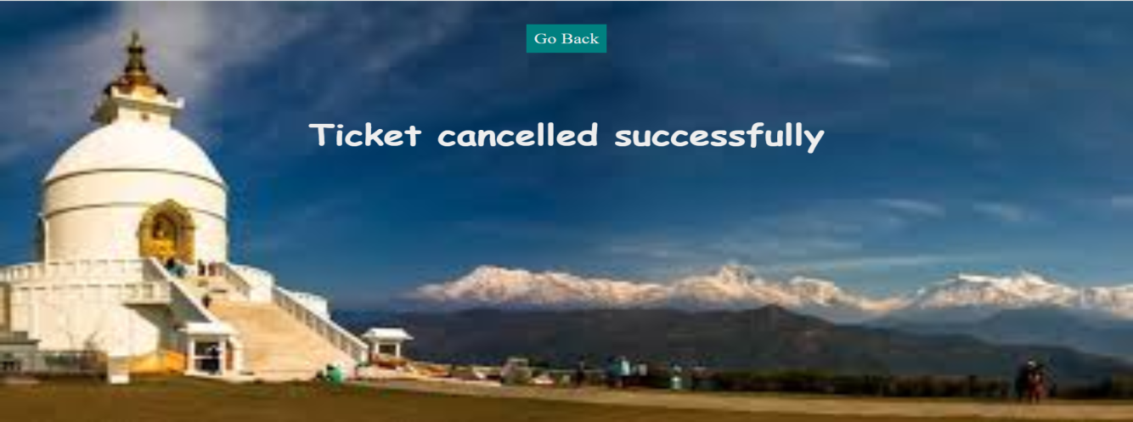

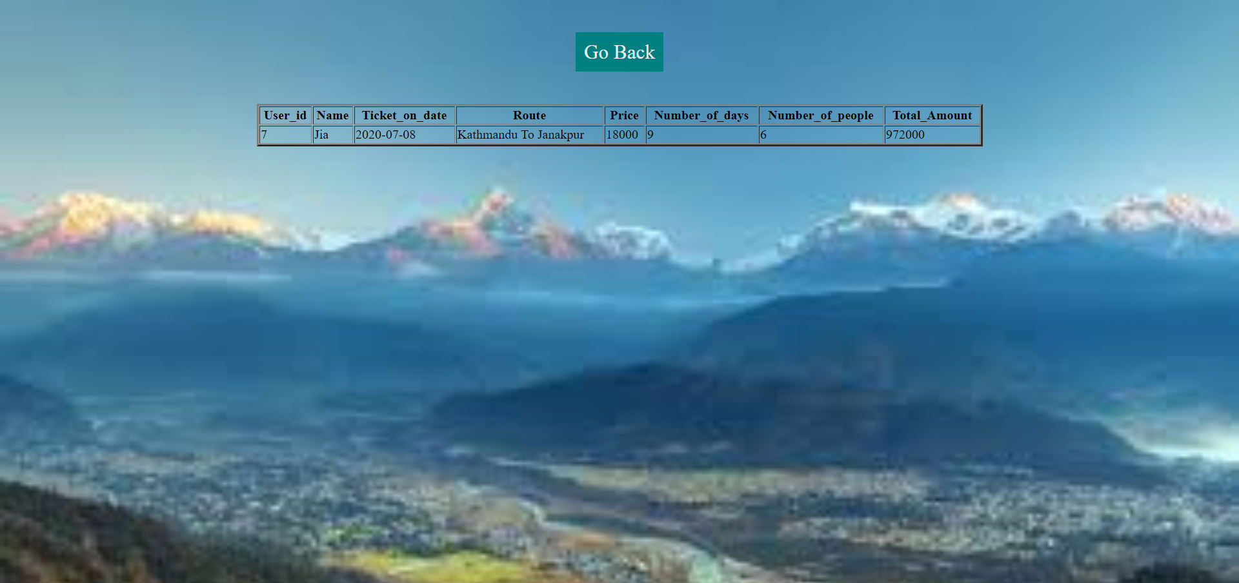

**Figure 3.2.3: Deletion of Ticket**

### 3.2.4 Update of Ticket

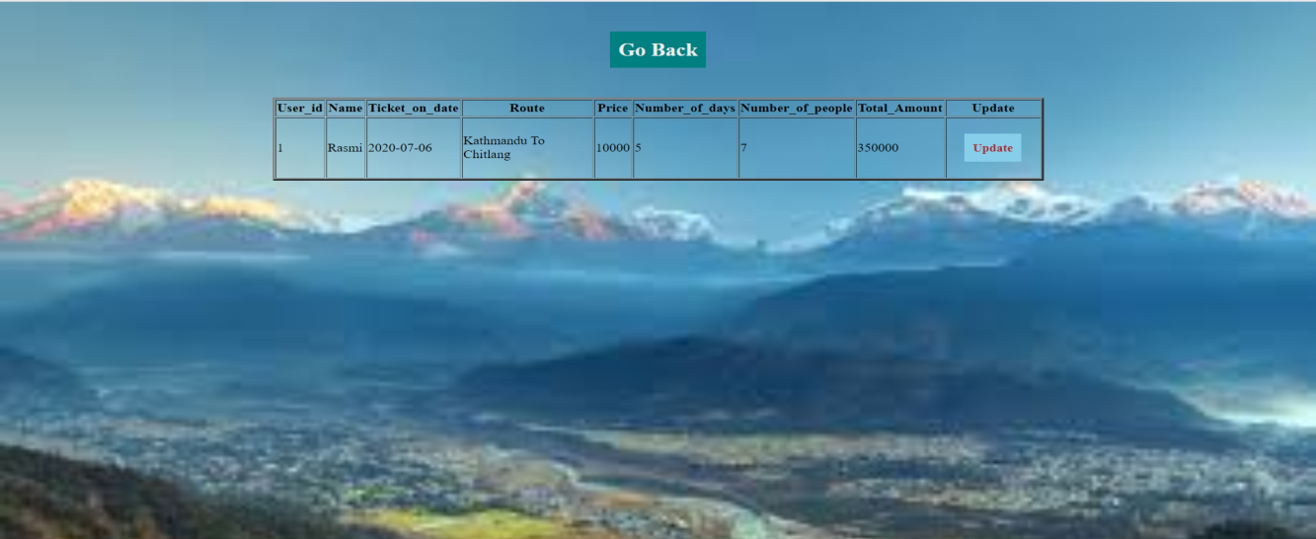

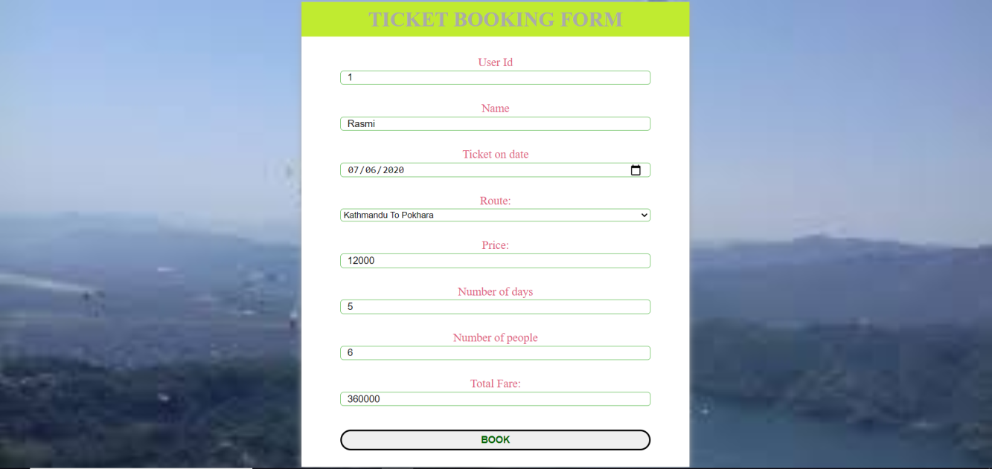

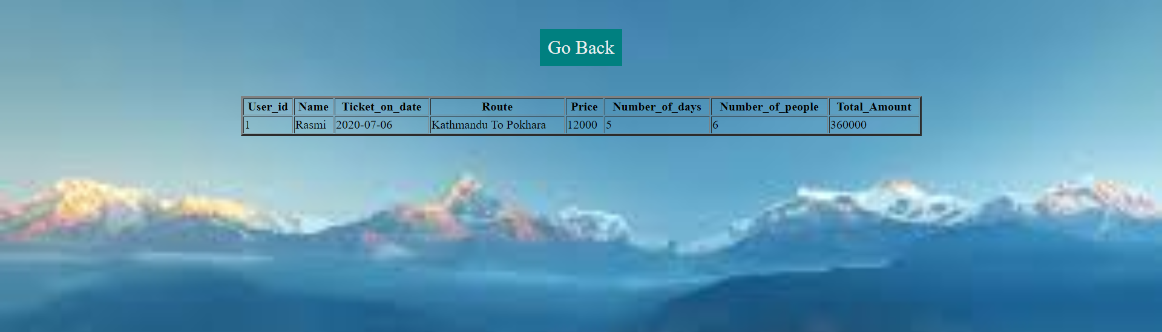

**Figure 3.2.4: Update of Ticket**

### 3.2.5 Account Deletion of Passenger

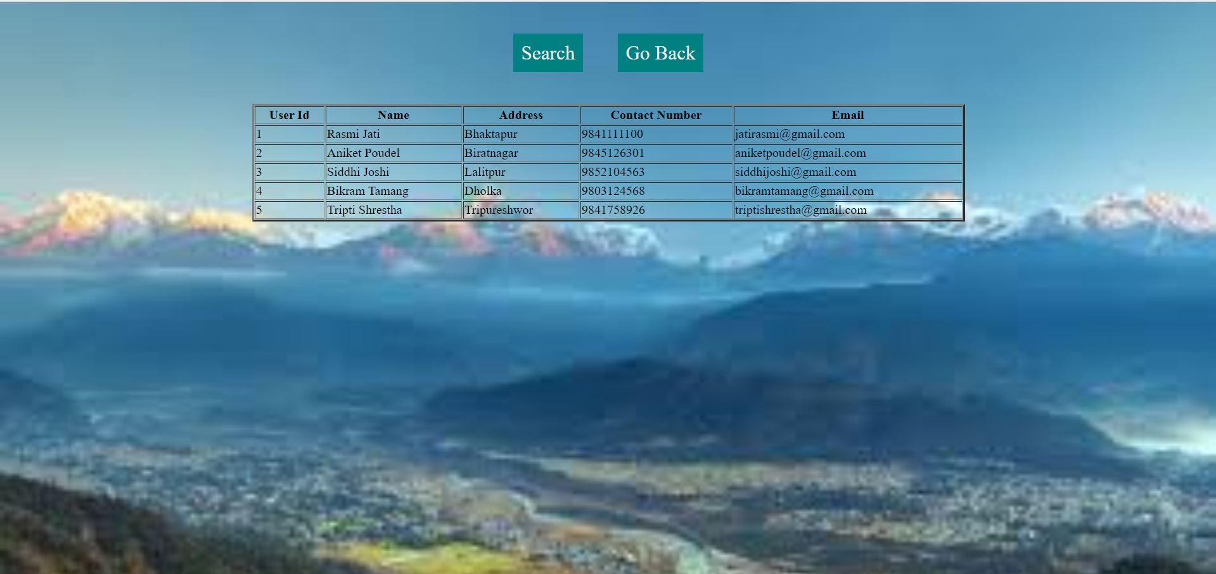

**Figure 3.2.5.1: List of Registered Passengers**

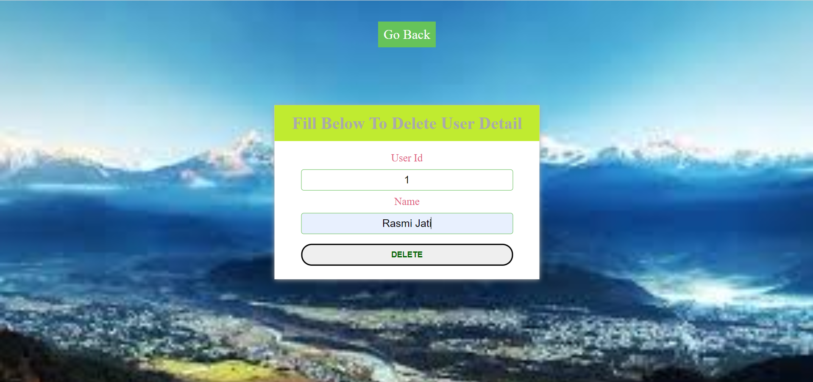

**Figure 3.2.5.2: Form to Delete Account of passenger**



**Figure 3.2.5.3: Message after Deletion of Passenger’s Account**

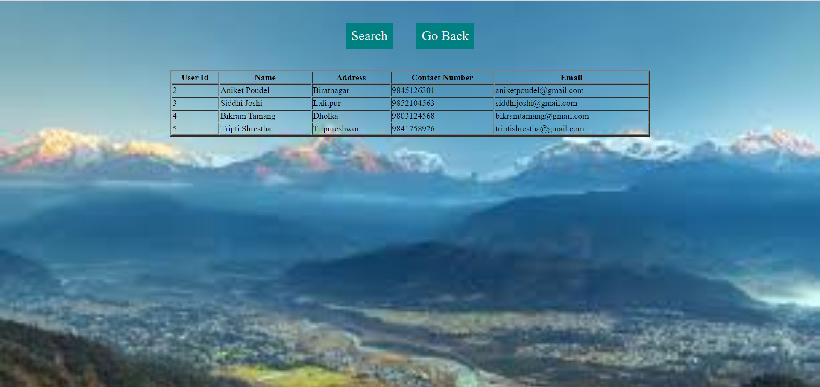

**Figure 3.2.5.4: List of Passengers after Deletion of a passenger**

# CHAPTER 4

# CONCLUSION

The developed system is very easy to use and time saving. It maintains the records of various passengers and provide quick services to the passengers. The user can book the tickets for their trip by using this system. This system is useful to the people who loves travelling and exploring new places.